Mechanical Engineering Department
To: David Michael Willy
From: Salar Golshan- NASA RASC Lunar Habitat
Date: 10/27/2021
Re: Analytical Task Assignment: Airlock Door
One of the most crucial aspects of the habitat is the integration of the airlock door into the design of the overall structure of the habitat. The depressurizing and the appropriate pressure values within the habitat, the material selection, dimensions, and CAD models, and details about the EVA (extravehicular activities). The habitat will consist of an airlock room where the astronauts will enter, get into their suits, depressurize the room, and exit the building through a pressurized door. The wall between the pressurized room and the natural habitat will consists of a suitport-airlock concept as well as an internal hatch door for the astronauts to move between the two rooms.
A suitport represents an easy access for the astronauts to enter their space suits for EVA. The suitport has an entrance from the natural habitat into the pressurized room, where the space suits will be held at. A visual representation of this model has been provided below.
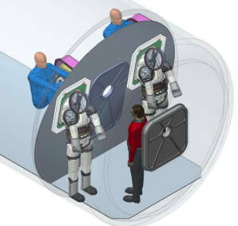
Figure 1. Suitport Airlock Concept [1]
In preparation for the extravehicular activities, during the spacesuits donning and doffing, the suitport airlock environment’s pressure will be brought down to roughly 8.2 psia with about 34% $O_{2}$.[1] The pressurized value within the environment is crucial for the limit pressure differential across the suits. Within the natural habitat, the normal air pressure should be held at 14.7 psia with the use of the ECLSS.[2] With this design, there are multiple benefits for the sustainability and efficiency of a long-term design. There will be much less gas loss, decreased exposure of harmful radiation, dust and particles to the spacesuits and important systems within the habitat due to the rapid ingress and egress.
The fine dimensions of the airlock room, ingress and egress of the room, as well as the method of entering the space suits for EVAs has been selected based on the research studies that has been conducted for deep space travel. The overall diameter of the airlock room will be roughly 3.5 meters, higher than the previous 3.0 meters in order to accommodate the hatch door placed in between the two suit-ports. Within the airlock room, there will be roughly $11m^{3}$ of internal volume space. To better assist the astronauts get into their suits easier, the suitports will be angled at a slight degree of roughly 20 degrees. Below is a visual representation of the fine dimensions of the initial airlock door and suit-ports.
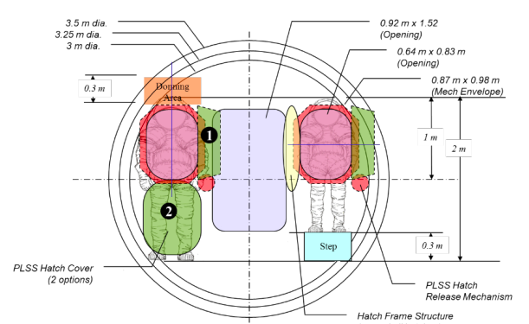
Figure 2. Rear Entry Airlock Dimensions [1]
Based on current models for microgravity operations on the ISS and other prototyped models throughout the years, the ingress and egress of the hatch is 40 inch x 40 inch in diameter.[3] The inner and outer hatch door assemblies which have been studied by NASA and multiple independent companies being in use right now in outerspace are both portrayed below.

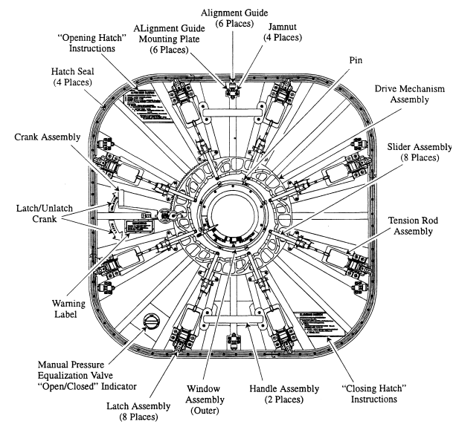
Figure 3. Outer Hatch Assembly [3]

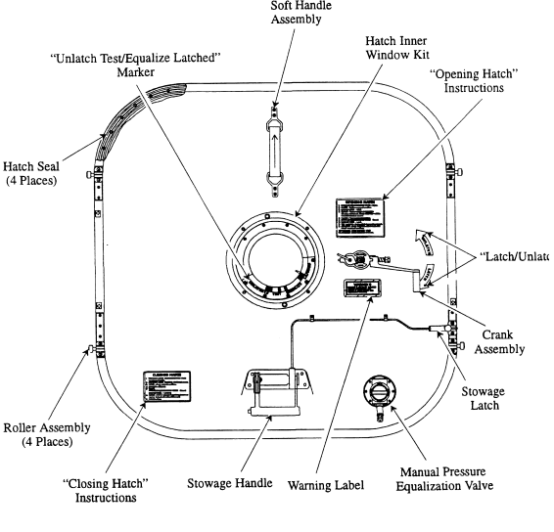
Figure 4. Inner Hatch Assembly [3]
During the EVA process, space dust can be picked up, kicked up and attached to the space suits which can be brough back into the habitat. Space dust is extremely harmful to the habitat environmental control system and is very harmful to the touch of the skin as it can ‘eat through’ the skin. The space suits require a cleaning after a consistent 30-day EVA on the face of the moon. Although since the whole duration of this mission is for thirty days on the moon, this will not be necessary for this current mission. Thus, there is an extensive cleaning process of the space suits once returning from EVAs. In order to combat this phenomenon correctly and efficiently, a “Layered Engineering Defense” plan has been generated.[1]
- 1st Layer – Mission Architecture Design
  - Avoidance of Special Regions (define within X Radius of Lander/habitat prior to the mission)
- 2nd Later – Hardware Design
  - EVA Suits will leak/vent – Engineering Limits must be understood and intentionally accounted for
  - Sample tool collection/containment
- 3rd Layer – Operational Design
  - Suit ingress directly to habitat volumes should be eliminated to extent possible, examples of this include ingress/egress method (don/doff through bulkhead)
  - Sampling Protocols limit inadvertent contamination
  - Leaving EVA suits on the surface prior to ascent to “break the chain” of contamination
- 4th Layer – Contamination Control
  - Conduct verifiable decontamination of EVA hardware on a regular interval
  - Conduct exterior and interior cleaning
  - Utilize Air Quality Contamination Zones
The Airlock mechanism is one of the strongest safe points on this habitat due to the crucial role it plays. It is the only aspect of the habitat that is meant to be released open unto space. If the safety factors of this design fail, it will threaten the astronauts lives before the human could understand what is going on. Thus, the design is an integration of generations of studies and proven methods for space travel whether on the current ISS methods or current methods being studied by NASA and hundreds of other independent companies worldwide. There is a clear-cut method for the astronauts to enter the airlock room with a simplified way of putting on their suits and entering the airlock at the same time. The team has also drafted through numerous variations of the airlock mechanism, dimensions and process and has determined that the methods presented in this memo best supports the astronauts safety, goals and supports the longevity of the design.

Sources
[1]
“Eva Office extravehicular activity (EVA) airlocks and ...,” NASA, 18-Apr-2018. [Online]. Available: https://www.lpi.usra.edu/lunar/constellation/Mary-2018-EVA%20Airlocks-And-Alternative-Ingress-Egress-EVA-EXP-0031.pdf. [Accessed: 26-Oct-2021].

[2]
K. Bascal, “[B!] https://www.faa.gov/about/office_org/headquarters ...,” CABIN ENVIRONMENT AND EVA ENVIRONMENT. [Online]. Available: https://b.hatena.ne.jp/entry/s/www.faa.gov/about/office_org/headquarters_offices/avs/offices/aam/cami/library/online_libraries/aerospace_medicine/tutorial/media/III.4.1.4_Describing_Orbits.pdf. [Accessed: 26-Oct-2021].

[3]
“Worldwide spacecraft crew hatch history - NASA,” NASA, Aug-2010. [Online]. Available: https://historycollection.jsc.nasa.gov/JSCHistoryPortal/history/oral_histories/JohnsonGW/NASA_TP-2010-216131.pdf. [Accessed: 26-Oct-2021].

